Experimental Study on the Dynamics and Thermal Behaviors of Colloidal Droplets in a Freezing-Based inkjet 3D Printing Method
Xiaoxiao Zhang, Yang Liu
Graduate Student, The City College of New York, U.S.A
Assistant Professor, The City College of New York, U.S.A

This study investigates the thermal and morphological behavior of colloidal droplets undergoing a freezing process on precooled substrates. We employed high-speed imaging and infrared thermography to capture phase change dynamics in droplets with varying concentrations. The experimental results revealed a radial freezing front followed by vertical solidification, significantly influencing particle distribution. A theoretical model was developed to predict freezing time and internal flow patterns based on Marangoni convection and Stefan number. Results suggest that higher colloidal concentration leads to a more compact dendritic core post-lyophilization. These findings offer insights for optimizing deposition patterns in freeze-based inkjet printing.
Keywords: freezing, colloidal droplet, Marangoni flow, heat transfer, lyophilization

Graphic Abstract (if any, limit within this page)

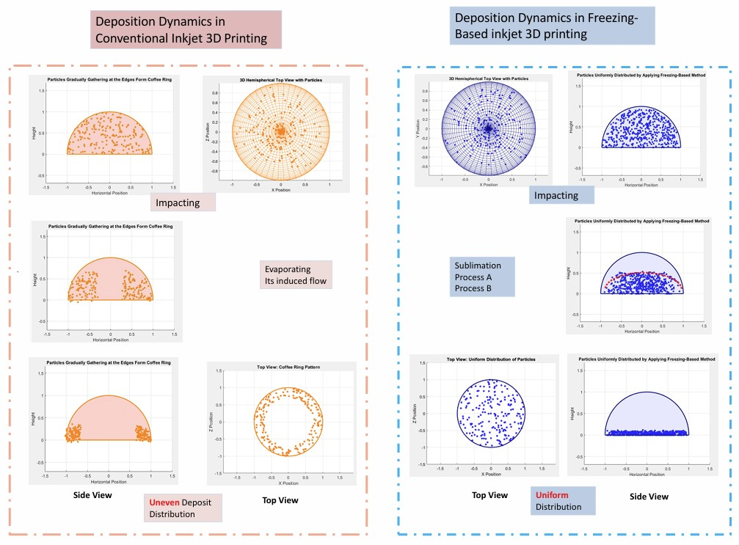
Schematic illustration of deposition morphologies in conventional and freezing-based inkjet 3D printing.

